Re-Wireable Surface-Mount Male Plug 16 Amps @ 250V - Commando (PWR-CMD-M12341)

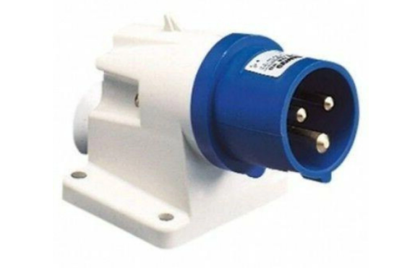

Description:
The LMS Power PWR-CMD-M12341 is a high quality, IP44 rated and completely
re-wireable 16 Amp Commando plug used for very high electrical load applications. The flush design means it can be mounted to an appropriate surface, either internally or externally.
The standard design used for power generation, power distribution extensions and other appliances that need the larger 16 Amp conformance standard.
Quality build assured, 16 Amp rated nickel pole design together with a large cable entry cross-section.

Key Features:
Standardised Commando Plug
Rated at up to 16 Amps up to 250 Volts
Fully re-wireable with screen down terminals
Surface Mounted Design
IP44 Weather proof rating

Applications:
Create bespoke electrical connections electrical systems
Create electrical connections for very high power appliances
Needed when separate electrical circuits are required

Product Code:
Part Number: PWR-CMD-M12341
EAN: 8400800037909
Weight: 0.2Kg approx

Technical Specifications:
Warranty LMS Data 2-Year Warranty
Chassis Thermoplastic, screw down housing
Load 16 Amps 250 Volts (Nominal)
Poles/Hours 2P+E/6H
Standards CE, Intertek Certified

Supplied With:
PWR-CMD-M32341 Surface-Mount Commando Plug
* Specifications and product design are subject to change. E&OE.

